**DOCUMENTATION**

**Full name:** Chandiwala Altamash Rizwan

**Project Name:** Amazon website

**Logo:**



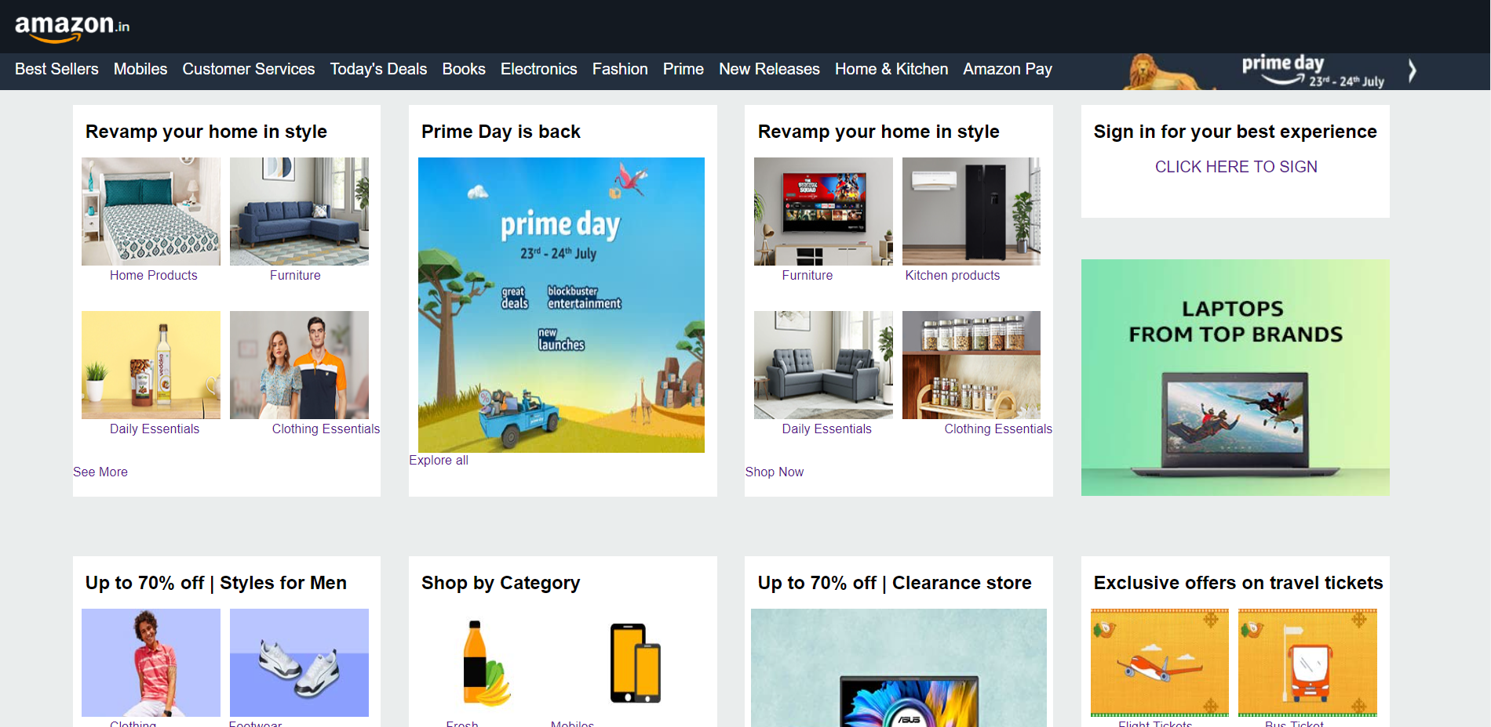

1.1 Amazon Homepage

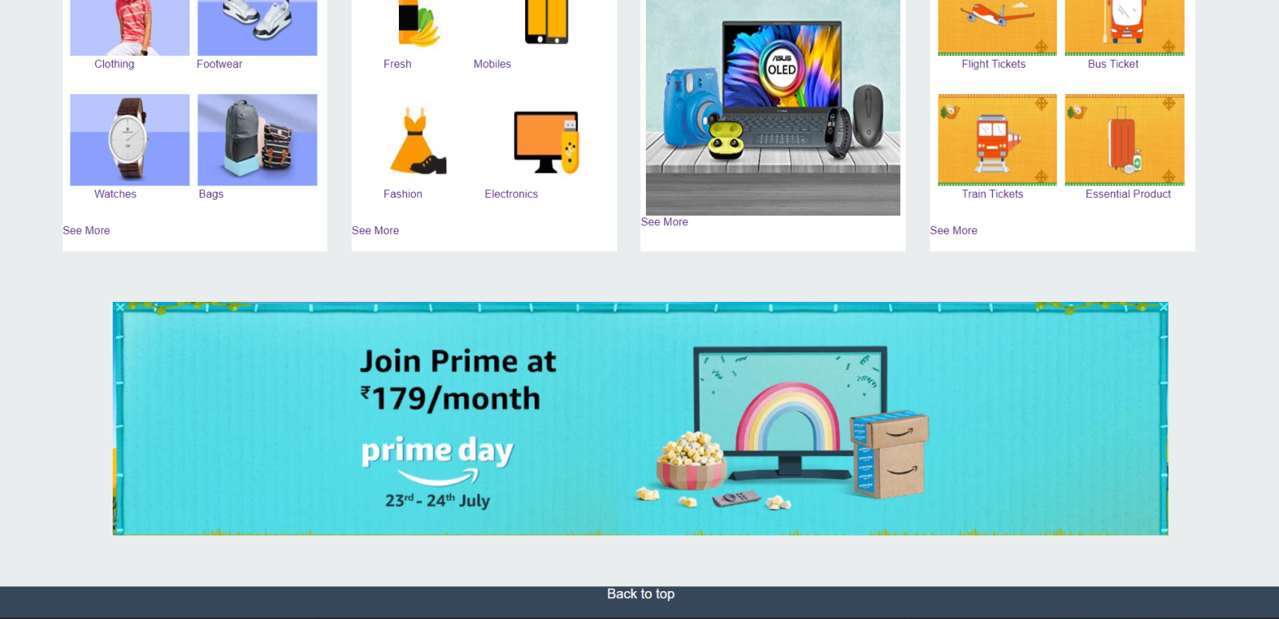

1.2 Amazon Homepage

**Overview:**

Amazon is an e-commerce website for both male and female ranging from a variety of items like clothing, footwear, accessories, etc. It doesn’t end here it also includes mobiles, computers, TV, appliances, electronics, etc.

1. **Homepage**

**Navigation Bar:**



1. Best Sellers:

Here customers can view all the best selling items of Amazon.

1. Mobiles:

In this section all the latest mobiles and upcoming smartphones are available with great deals.

1. Customer Services:

This section includes all the frequently ask questions and many other things like tracking orders, returns & refunds , payment settings, etc.

1. Today’s Deal:

Here everyday new and exciting deals are given to customers on all types of products.

1. Books:

A variety of types of books are available in this section ranging from kids to novels and many other.

1. Electronics:

Electronics items includes mobile, TV, pen drives, hardisk, earphones, smartwatches, etc.

1. Fashion:

In the fashion section here all the clothing, footwear and accessories for males, females and kids are seen.

1. New Releases:

All the newly released items in mobiles, TV, gaming consoles, fashion accessories are listed here.

1. Home & Kitchen:

In this section all home appliances and kitchen appliances are categorized into separate sections so that it is easy for the customers to pick what’s right for them.

1. Amazon Pay:

Amazon has it’s own payment method namely Amazon Pay where user can hassel freely make payments, here instructions and guides are available to activate one.

Lastly, Prime day sales offers great deals on products and faster delivery options where the user have to enrolled themselves in this program with a minimal fee per month.

For better user experience separate divisions are made for the users. This helps the users to get what they are looking for easily without consuming a lot of time. As mentioned below:

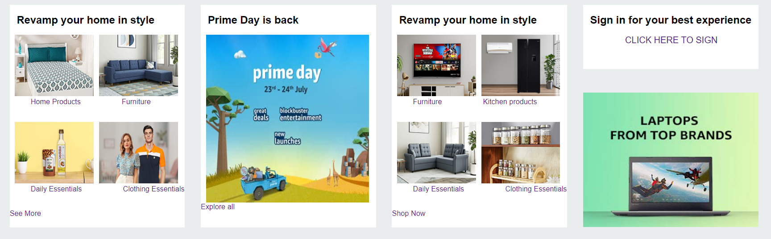

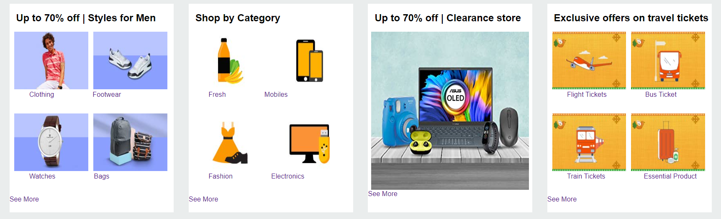

Amazon also provides options to book a flight, bus or trains with great offers where user can benefit themselves by saving money.



A back to top option is available where user again go back to the top of the page where they started the search.